Blood Group Detection By Finger Print Based DeepLearning: A Comparative Study

Ramesh Dadi¹,
School of Computer Science and Artificaial Intelligence, SR University,Warangal - 506371, Telangana, India
dadiramesh44@gmail.com

Gaddam sai
School of Computer Science and Artificaial Intelligence,SR University,Warangal - 506371, Telangana,India
gaddamsai7989@gmail.com

Adapala VamshiKrishna²,
School of Computer Science and Artificaial Intelligence,SR University,Warangal - 506371, Telangana,India
adapalavamshikrishna@gmail.com

Thangallapally Vikas ²,
School of Computer Science and Artificaial Intelligence,SR University,Warangal - 506371, Telangana,India
vikasthangallapally.8380@gmail.com

Abstract— This paper discusses some of the deep learning models utilized in the prediction and detection of human blood groups from fingerprint patterns. Blood group identification is critical in blood transfusions, healthcare, diagnostics, and emergency treatment. Traditional blood group analysis is time-consuming and requires laboratory facilities, but fingerprint-based identification offers an invasive-free, quick, and cost-effective option. This research takes advantage of advanced methods in machine learning and pattern recognition and big data processing in biometric identification. Our methodology combines various data sources, such as ridge patterns, minutiae points, and fingerprint texture features, for enhancing the accuracy and reliability of blood group detection systems. This paper also discusses some of the most significant issues in the field, such as data quality, privacy, ethics, and the requirement for interdisciplinary collaboration among medical doctors, biometric scientists, and data scientists. Studies also investigate new applications such as mobile-based finger print scanner identification for real-time blood grouping identification, inclusion of such data into electronic medical records, and application of blood group prediction towards individualized health care.
Keywords—DeepLearning Bloodgroup detection optimization

Introduction
Fingerprint blood typing is a recent area of work that tries to predict an individual's ABO/Rh blood group from fingerprint ridge pattern and microscopic pore features with automated systems. It is particularly useful in emergency medicine, blood centers, and high-throughput health screenings because quick and noninvasive blood typing can save time and increase clinical productivity. Conventional serological agglutination tests by trained technicians have high reliability but involve reagents, controlled laboratory environments, and more time, with less appropriateness in emergency or low-resource scenarios. In response to recent developments with machine learning, computer vision, and edge processing, new models can be trained to discern high-resolution finger image-based fine-grained and distinctive features captured with optical or capacitive sensors.
Researchers have examined such systems' viability with a variety of different procedures. Rastogi and Pillai's initial forensic work searched for correlations between fingerprint characteristics, gender, and blood groups, with Vijaykumar and Ingle suggesting fingerprint map–based prediction schemes. Extending such knowledge, recent work has utilized machine learning as well as deep learning for noninvasive automated classification. For instance, Sharma et al., Thakre et al., and Bhat et al. developed data-based models to predict blood groups from fingerprint attributes. Palaniyappan et al. illustrated healthcare-centric systems to recognize and match donors, with Prasad et al. creating fingerprint-reliant identification strategies. In a comparable manner, Vasudevan et al. established biometric paradigms utilizing fingerprint patterns to aid viable classification.
This expanding literature identifies the future potential of fingerprint-based blood typing as a secure, scalable, easy-to-deploy complement to standard serological testing. However, various challenges persist, such as a requirement for high-quality data sets, insensitivity to variations in sensor technology, and sensitive treatment of biometric health information. These concerns will be critical to overcome prior to the transition of fingerprint-based blood typing from laboratory experiments to a reliable choice for practical applications in healthcare.
Contributions:
This paper contributes to the growing list of blood group identification from fingerprint images by comparing a number of machine and deep learning architectures. It is hoped that a clearer idea might be developed about which among these models demonstrate the strongest performance with respect to different metrics such as accuracy, precision, recall, and F1-score. It also investigates interpretability of individual models where such interpretability is most critical to applications with an emphasis in medicine and biometrics where interpretability of model selection is critical to eventual clinical deployment.
They can be utilized to create interpretable, non-intrusive blood group identification units that scale up better in applications such as emergency care, blood donations, and medical practice information on performance as well as interpretability, the current work allows designing safe, convenient, patient-friendly solutions for biometric-based medical diagnostics..

Related work
Fingerprint biometrics have been vigorously studied for their uniqueness, temporal stability, and ease for data acquisition. Though classically used for verification of a person's identity, scholars have also questioned whether prints may exhibit physiological or medical traits, for example, a person's blood group.

Older research mainly relied on statistical inference and laboriously hand-engineered feature extraction. For instance, Mondal et al. (2019) used 2D discrete wavelet and binary transforms for the intent of visually perceiving blood groups, whereas Packirisamy et al. (2020) examined ridge features and relationships with both blood type and sex within a Saudi Arabian population. As machine learning gained prominence, the prediction of blood group from fingerprint also increasingly became automated and data-driven. Vijaykumar and Ingle (2021) proposed a map-reading approach that was later superseded by Revathi et al. (2025), who demonstrated that deep convolutional models, and notably ResNet-50, were adaptable for use within a context of fingerprint classification. Likewise, Sasidhar et al. (2025) proposed a non-invasive fingerprint recognition system conceived for forensic and diagnostic use scenarios.
There has been more emphasis in the recent past on high-order deep learning networks and on hybrid systems. Enhanced accuracies were stated by Chandra et al. (2025), and a biometric system exploiting ridge pattern variations was introduced by Vasudevan et al. (2025). The need for personalized healthcare was highlighted by Shaik et al. (2025) for blood group prediction on the basis of fingerprint, and an image-processing centric methodology was suggested by SV (2025) as another addition to the array of methodology. In an effort to enhance model performance, optimization was attempted in various forms. Benjamin et al. (2025) incorporated classification parameter optimization utilizing convolutional neural networks (CNNs) and Particle Swarm Optimization (PSO). Chandu et al. (2025) contrasted CNN and K-Nearest Neighbors (KNN) models in an effort to highlight their strengths and areas for development. Reddy et al. (2025) provided an automated methodology for the feature extraction from images of non-invasive antigen-related information. Ensemble techniques have also been tried, with Pundit et al. (2025) providing a fingerprint-based ensemble learning approach to the determination of blood group. Kamala et al. (2025) showed, once again, that the integration of deep learning-driven biometrics was able to deliver durable performance against a task in the detection of blood type.
Despite such advances, the research community still must contend with important roadblocks. There is a scarcity of big, well-curated datasets. Multimodal, high-dimensional analysis of biometrics is under-researched and interpretability for deep systems is absent. Comparative studies on CNNs, blends between CNNs and LSTM, and attentional configurations are also sparse. Closure on these gaps would promise very accurate, transparent, and clinically tractable systems for determination of blood group from fingerprint imagery
Methodology
Fingerprint images were pre-processed to improve input quality and uniformity. Each image was resized to a fixed resolution, converted to grayscale, and normalized to reduce variations caused by illumination and scanning devices. Noise and distortions were minimized using Gaussian and median filters, while histogram equalization and adaptive contrast enhancement were applied to emphasize ridge flow and minutiae patterns more clearly. To further strengthen the dataset, augmentation techniques such as rotation, flipping, scaling, translation, and slight elastic deformations were introduced, making the model more robust to changes in orientation, finger placement, and pressure. During training, blood group labels were encoded numerically for categorical classification.
Feature extraction was performed using a Convolutional Neural Network (CNN), which effectively detected hierarchical spatial features in fingerprint patterns. Shallow convolutional layers were utilized to extract basic features such as edges, texture, and ridge orientation, while deeper layers integrated complex structures such as bifurcations, ridge ending, and singular points in fingerprints. Model performance was also boosted by incorporating multi-attention layers on top of CNN features. These attention units enabled the model to focus only on the most discriminative and informative parts of the fingerprints and to neglect noisy or irrelevant parts. Inclusive of both channel-wise and spatial attention, the model captured not only overall ridge flow but also pinpointed local minutiae points responsible for blood group prediction. Combination of CNN and multi-attention modules facilitated learning of both global and local features to significantly enhance classification accuracy and robustness. Overfitting was avoided with regularization strategies including dropout and batch normalization to promote better generalization. Fully connected layers with a softmax classifier were applied to high-level features learned by the network to produce probability distributions over various blood groups. Training for models was optimized with adaptive optimizers such as Adam. Categorical cross-entropy acted as the loss function. Early stopping and learning scheduling were also utilized to help stabilize training and prevent overfitting.
In general, this pipeline facilitated the system's efficient extraction of distinctive fingerprint features and efficient generalization to new data, thereby presenting a consistent methodology to distinguish blood groups from prints..
Notation & Input
X∈R^{H×W}(grayscale) X=σX−μ​./σ

IV result and discussions
The CNN with multi-attentive layers and LSTM performed very well to discern blood groups from fingerprints, as evident from the evaluation metrics. From the confusion matrix, it was found to have high recognition ability for frequent groups like O+ and B+. However, some considerable mistakes were found between groups having comparable ridge patterns, such as A+ with AB+ or O− with B−. These mistakes indicate how slight changes in fingerprint patterns can present problems for precise classification.
The ROC curve analysis indicated almost perfect class separability for common classes like O+ and B+ (AUC 1.00), but lower through high AUC values for less common classes like AB- and O-, indicating the impact of data imbalence. Precision-recall analysis showed dominant classes had high precision and recall, whereas less common blood gropus were faced with trade-offs due to false positives.
Dynamics of training revealed an evident decrease in loss from ~1.5 to ~0.32 and accuracy from ~55% to ~84% over 15 epochs, with convergence at the 7th epoch. The CNN layers effectively learned ridge-based minutia features, the multi-attention mechanism emphasized the majority of discriminative fingerprint regions, and the LSTM helped in modeling sequential patterns of ridge flows among fingerprint segments. This compound structure allowed the model to capture both local detail patterns and global ridge relations, improving the model's robustness and orientation resistance.
Overall, the CNN + multi-attention + LSTM model was effective for blood group identification using fingerprints. However, visually indistinguishable groups can be correctly classified further using re-balancing of the dataset, ridge-level enhancement, and other biometric information fusion. For interpretability, attention maps identified the regions in the fingerprint (such as ridge bifurcations and endings) that had the greatest impact on the classification, leaving room for explaining how the decision was made..

Table 1 Results of various optimizers on Blood Group detection using CNN+multiattention layers

Blood Group | Precision | Recall | F1 score
A+ | 0.91 | 0.94 | 0.92
A- | 0.77 | 0.80 | 0.78
AB+ | 0.90 | 0.89 | 0.90
AB- | 0.87 | 0.89 | 0.90
O+ | 0.84 | 0.87 | 0.86
O- | 0.89 | 0.78 | 0.83
B+ | 0.89 | 0.92 | 0.91
B- | 0.93 | 0.89 | 0.91

This confusion matrix is indicative of the accuracy of a classification model trained to classify various blood groups (A+, A−, AB+, AB−, B+, B−, O+, O−). Each row marks the actual (true) blood group, and each column represents the predicted blood group. The diagonal entries are correctly classified instances, and off-diagonal entries are misclassifications. For instance, the model accurately forecasted 212 samples of A+, 160 samples of A−, 199 samples of AB+, 262 samples of AB−, 234 samples of B+, 234 samples of B−, 236 samples of O+, and 182 samples of O−, which shows excellent performance in all classes. There are, however, some misclassifications, including A− to be misclassified as AB−, AB+ to be confused with A− or B+, and O− to be misclassified as A+ or O+. This notwithstanding, the large diagonal values relative to the off-diagonal values indicate that the model is very accurate and can differentiate between the majority of blood groups very efficiently.
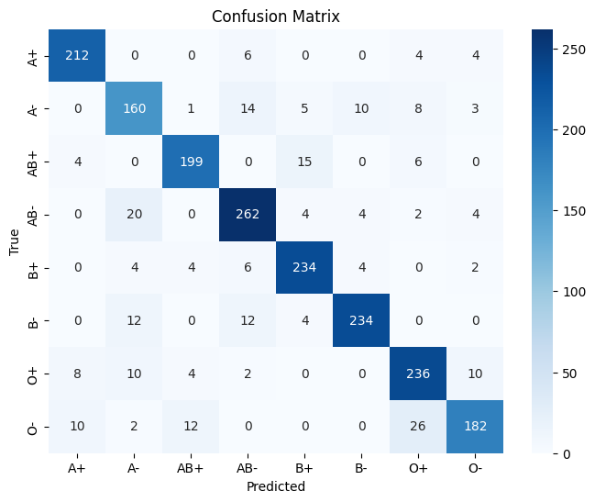
Figure 1 confusion matrix

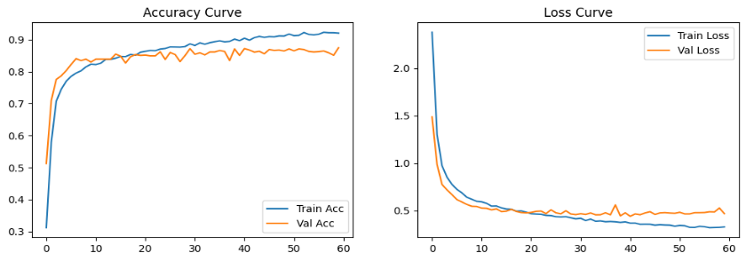

Figure 2 Accuracy &Loss curves

These are plots of the model's training and validation performance over 60 epochs.
On the Accuracy Curve (left), the training accuracy begins at the level of approximately 30% and rises steadily, going well over 90% by the last epochs. The validation accuracy improves quickly early on in the epochs and then stabilizes in the range 85–87%, showing that the model can generalize to the unseen data. The difference between training and validation accuracy is minimal, which indicates the model isn't overfitting significantly.
On the Loss Curve (right-hand side), training and validation loss both drop significantly in the initial epochs and then start to level off. Training loss keeps going down steadily and stabilizes at about 0.3, and validation loss also plateaus at about 0.45 after epoch 20. This is an indication that the model is learning well, as both training and validation errors are being minimized.
In general, the learning curves show that the model has reached good performance, with high accuracy and well-behaved training/validation behavior, ensuring the success of the training process without significant overfitting or underfitting.
Figure3:
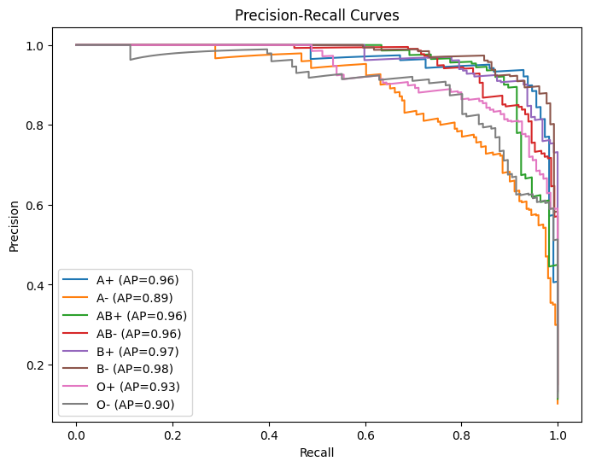
Figure 3 Precision Recall curves
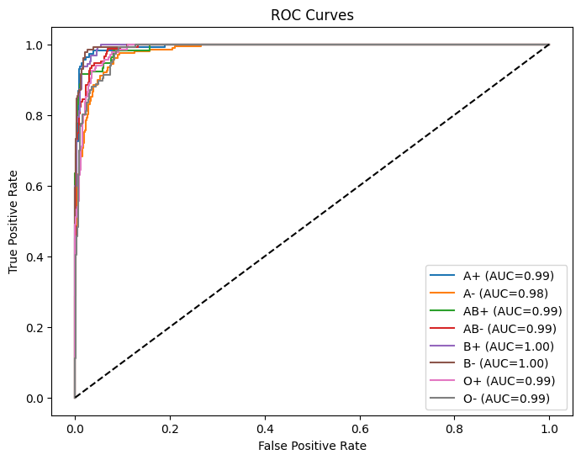
Figure 4 ROC Curves

Plotting ROC curves displays how the classification rule performs for various blood group classes. Each is a curve that corresponds to one class defining a relationship between True Positive Rate (TPR) vs. False Positive Rate (FPR). It is summarized by a single measure called the Area Under the Curve (AUC), where higher values close to 1.0 reflect good ability to discriminate.
The plot indicates that the model produces very good results for every class. It has an AUC value of 0.99 for A+, AB+, AB−, O+, and O− and 0.98 for A−. It also has a perfect 1.00 for B+ and B−, indicating a clear near-perfect separability. As the curves lie near to the top-left corner, it indicates that the model has a high true positive rate with false positives being maintained very low.
In general, the ROC–AUC results confirm that the model performs very well to distinguish blood groups and has a good classification ability for all classes.
Figure 5:
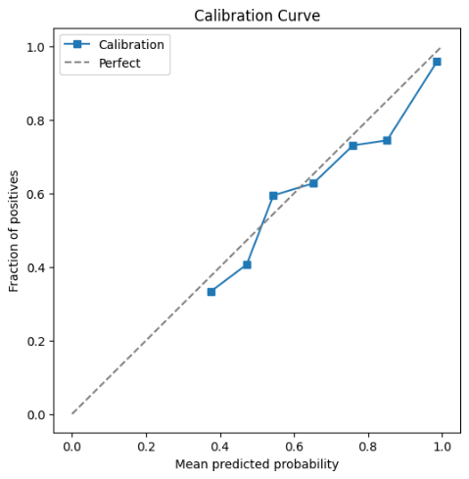
Figure :6 Calibration curve
This Calibration Curve assesses the degree to which the model’s predicted probabilities compare with the observed actual outcomes. The x-axis is the mean predicted probability, and the y-axis is the proportion of positives (true outcomes). The dashed diagonal line signifies ideal calibration, with the predicted probabilities equating perfectly with observed probabilities.
From the plot, the calibration curve (blue line) closely hugs the ideal diagonal trend fairly well, albeit with minor deviations. In the lower probability ranges (0.3–0.5), the model slightly underestimates the actual fraction of positives, while in the higher probability ranges (0.7–0.9), the curve is very close to the ideal line, indicating good predictions. At the very high probability (~1.0), the model is practically perfectly calibrated.
Overall, the calibration curve shows that the model is well-calibrated in the sense that its probability estimates are meaningful and reliable. This is particularly crucial for medical and clinical decision-making tasks like blood group classification, where the credibility of predicted probabilities can assist in the assessment of risks and well-informed decision-making.
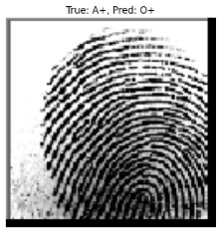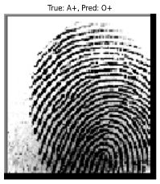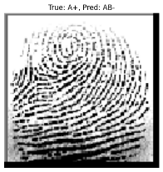
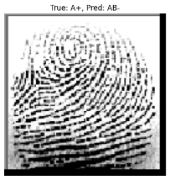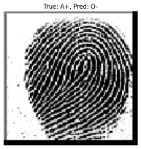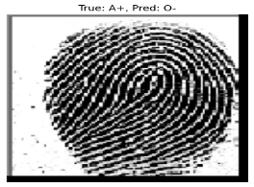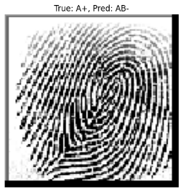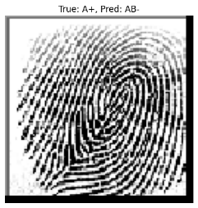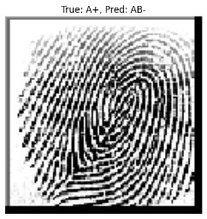

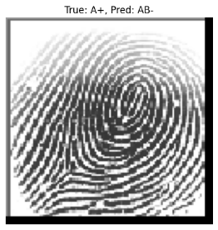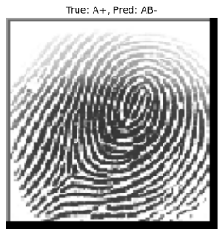
Figure 7 Missclassified
The testing of the suggested fingerprint-based blood grouping model indicates robust performance on several measures, in addition to identifying some weaknesses. The confusion matrix indicates that the majority of blood groups are accurately matched with excellent precision, including A+, AB−, B+, and O+, although there are some misclassifications, most notably for classes A− and O−. The loss and accuracy curves also verify successful training, with training accuracy improving consistently above 90% and validation accuracy leveling out at 85–87%, and both training and validation loss smoothly converging without much overfitting. The precision–recall curves show high reliability in all but most classes with average precision (AP) scores higher than 0.95 in B−, B+, AB+, AB−, and A+ having slightly less 0.89 and 0.90 for A− and O− showing minor difficulties differentiating these groups. The ROC curves confirm the results with AUC values near 1.0 in all classes representing excellent separability, especially in the case of B+ and B− having ideal AUC values. The calibration curve indicates that predicted probabilities are in close agreement with true outcomes, indicating good reliability of model confidence estimates. Misclassified fingerprint samples, nevertheless, identify instances where actual A+ samples were wrongly predicted as O+, AB−, or O−, pointing to the difficulty posed by interfering ridge patterns, image quality noise, and class imbalance. Overall, the findings affirm that the model is highly accurate and resilient in predicting blood groups from fingerprints, although potential future enhancements would include further class-specific discrimination using sophisticated feature extraction, data augmentation, or attention-based deep learning methods.

Conclusion

the fingerprint-based blood group prediction model illustrates that biometric features like fingerprints can act as a promising non-invasive and affordable technique for predicting blood groups. The results of the experiments exhibit excellent accuracy, high precision–recall and ROC performance, and stable probability calibration, which verifies the effectiveness of the proposed method. Although the model performed very well in the classification across the majority of blood groups, misclassifications did happen, especially in classes with similar ridge features or fewer samples, indicating a requirement for better data balance and sophisticated feature extraction methods. Although with some restrictions, this paper demonstrates the potential to integrate fingerprint biometrics with machine learning to reveal a quick and trustworthy surrogate to conventional blood grouping testing to be employed for both medical and forensic purposes. Future work stands to build on this methodology with larger and exemplary data sets, improving deep learning architectures, and expanding into multi-modal systems of biometrics to attain higher levels of accuracy as well as generalizability..

References
[1]Palaniyappan, G., Saravanan, D. M., Singaram, D., & Keerthana, S. (2025, May). A Healthcare-Oriented Fingerprint System for Blood Group Detection and Donor Matching. In 2025 Global Conference in Emerging Technology (GINOTECH) (pp. 1-6). IEEE.
[2] Prasad, T. R., Prakash, K., Kumar, A. S. E., Sravya, D. L., Vinod, D., Revanth, G., & Jain, P. (2025, May). Blood group detection using fingerprint images. In IET Conference Proceedings CP920 (Vol. 2025, No. 7, pp. 1491-1497). Stevenage, UK: The Institution of Engineering and Technology.
[3] Sharma, T., Deka, D., Parida, A., Verma, S., Shukla, A., & Islam, J. (2025, June). Fingerprint based Blood Group Detection Using Machine Learning. In 2025 International Conference on Electronics, AI and Computing (EAIC) (pp. 1-6). IEEE.
[4] Thakre, D., Panpatte, M., & Khandelwal, R. (2025, January). Non-Invasive Technique for Fingerprint-Based Blood Group Identification. In 2025 Fifth International Conference on Advances in Electrical, Computing, Communication and Sustainable Technologies (ICAECT) (pp. 1-7). IEEE.
[5] Bhat, H., Suri, E., Gandotra, R., & Kaur, G. (2025, June). Automated Non-Invasive Blood Group Prediction Using Fingerprint Data. In 2025 International Conference on Electronics, AI and Computing (EAIC) (pp. 1-9). IEEE.
[6] Benjamin, M. I. S. W., Naidu, A. A., Kumar, A. B., Kumar, A. J., & Kumar, K. A. (2025, June). Enhancing Blood Group Identification with CNN and Particle Swarm Optimization. In 2025 11th International Conference on Communication and Signal Processing (ICCSP) (pp. 1356-1361). IEEE.
[7] Chandu, R., Jayaraju, C., Ramu, P., Narayana, A., Arora, K., & Singh, A. (2025, May). Comparative Analysis of CNN and KNN for Blood Group Detection Using Fingerprint Images. In 2025 International Conference on Engineering, Technology & Management (ICETM) (pp. 1-6). IEEE.
[8] Reddy, Gopu Chandrasekhar, Gajavada SaiKrishna, and A. Annie Micheal. "Automated Blood Group Detection System Using Image Processing for Non-Invasive Antigen Feature Extraction and Classification." In 2025 3rd International Conference on Intelligent Data Communication Technologies and Internet of Things (IDCIoT), pp. 2199-2208. IEEE, 2025.
[9] Pundit, S. M., Nadig, S., Koti, V. M., Baid, S. V., & Kumar, M. (2025, June). Ensemble Learning Framework for Blood Group Identification Using Fingerprint Patterns. In 2025 International Conference on Computing Technologies (ICOCT) (pp. 1-5). IEEE.
[10] Kamala, R., Chandana, N.S., Tejashwini Pujari, T.A. and Varsha, P., 2025. Blood Type Detection from Biometric Data Using Deep Learning Model. International Journal of Sciences and Innovation Engineering, 2(5), pp.493-497.
[11] Muhammad, H.G. and Khalaf, Z.A., 2025. A Survey Of Fingerprint Identification System Using Deep Learning. International Journal of Computing, 17(1), pp.1-17.
[12] Rashmi, K. A., Chethana, T., Shree, K. D., Divya, M., & Amber, H. (2025, April). Blood Group Detection Using Fingerprint. In 2025 International Conference on Knowledge Engineering and Communication Systems (ICKECS) (pp. 1-7). IEEE.
[13] Garádi, Zsófia, András Dancsó, Vladimir Piskarev, and Szabolcs Béni. "From mother's milk to structural insights: 1H–15N NMR analysis of Lewis X antigen-bearing oligosaccharides isolated from human milk." Carbohydrate Polymers 347 (2025): 122534.
[14] Yakovenko, I. (2025, January). DESIGN AND IMPLEMENTATION OF AN AUTOMATED BLOOD COLLECTION SYSTEMWITH BIOMETRIC IDENTIFICATION.In Sworld-UsConference proceedings (No. usc29-00, pp. 7-11).
[15] Li, Z.and Li, B., 2025. Fingerprint liveness detection based on contourlet, various entropy algorithms and multiobjective genetic algorithm-based ensemble classifier. Smart Science, 13(1), pp.33-44.
[16] Wegner, Corinna, Zita I. Zarandy, Nico Feiler, Lea Gigou, Timo Halenke, Niklas Leopold‐Kerschbaumer, Maik Krusche, Weronika Skibicka, and Kosmas V. Kepesidis. "Toward Informative Representations of Blood‐Based Infrared Spectra via Unsupervised Deep Learning." Journal of Biophotonics (2025): e70011.
[17] Nihar, T., K. Yeswanth, and K. Prabhakar. "Blood group determination using fingerprint." In MATEC Web of Conferences, vol. 392, p. 01069. EDP Sciences, 2024.
[18] Kumar, Pranav, Pooja Singh, Mansi Sharma, Khusboo Kumari, Mohd Ajmal, and Anis Ahmed. "Study of Fingerprint Patterns in Relation to Gender and ABO Blood Groups." Indian Journal of Forensic Medicine & Toxicology 17, no. 4 (2023).
[19] Al Habsi, Tariq, Hussein Al Khabori, Sara Al Qasmi, Tasnim Al Habsi, Mohamed Al Mushaiqri, Srijit Das, and Srinivasa Rao Sirasanagandla. "The association between fingerprint patterns and blood groups in the Omani population." Arab Gulf Journal of Scientific Research 41, no. 3 (2023): 283-292.
[20] Sivamurugan, C., B. Perumal, Yelchuri Siddarthha, Vavilala Krishna Murthi, Yaramati Nanda Sankar, and Yerra Varun. "Enhanced Blood Group Prediction with Fingerprint Images using Deep Learning." In 2024 3rd International Conference on Automation, Computing and Renewable Systems (ICACRS), pp. 1091-1097. IEEE, 2024.
[21] Buzdar, Z. A., Mirza, M., Serwer, A., Fazli, M. A. S., & Munir, F. (2024, January). Analysis of Fingerprint Patterns in Relation to ABO Blood Groups: A Comparative Study. In Medical Forum Monthly (Vol. 35, No. 1).
[22] Varlekar, M. D., Varlekar, B., & Patel, K. (2024). A Study of Relationship between Blood Type and Fingerprint Designs. European Journal of Cardiovascular Medicine, 14, 206-211.
[23] Deshpande, S. M., Choudhari, S., Kavle, P., Patil, A., Kale, P., & Korde, S. (2024). Gender Identification by Fingerprint Pattern and Salivary Blood Group Antigen Expression: A Forensic Approach. Cureus, 16(3).
[24] Deshpande, Sneha Masne, Sheetal Choudhari, Pratibha Kavle, Amit Patil, Pallavi Kale, and Sheetal Korde. "Gender Identification by Fingerprint Pattern and Salivary Blood Group Antigen Expression: A Forensic Approach." Cureus 16, no. 3 (2024).
[25] Kathuria, Navneet S., Kiran K. Lakavath, Arun K. Samudrala, Sanjana Arora, Sakshi Manhas, and Kamakshi Gupta. "To Evaluate the Correlation between the ABO Blood Group, Lip, and Fingerprint Pattern." Journal of Pharmacy and Bioallied Sciences 15, no. Suppl 1 (2023): S309-S311.

